FIRST Global Challenge Host Bid Package

Overview

The FIRST Global Challenge is an annual international Olympics-style robotics competition where one team from every nation is invited to participate. Pre- and post-pandemic, this exciting sports competition has been held in several different cities including Washington, D.C., Dubai, Singapore, and Geneva.

The FIRST Global Challenge is organized by FIRST Global, a United States-based not-for-profit organization designed to inspire the next generation of youth to pursue careers in Science, Technology, Engineering, and Mathematics (STEM). The FIRST Global Challenge builds bridges between high school students with different backgrounds, languages, religions, and customs. In order to support this effort, FIRST Global invites over 250 volunteers from all over the world to be an integral part of the event in technical and nontechnical areas. This competition is also a powerful example of the great things that we can do when we come together for a common goal.

While primarily organized by FIRST Global, the competition and peripheral events will require support from, and coordination with, the Host city and additional vendors. Below are the specifications required for the FIRST Global Challenge, along with response information.

For additional information, see the following links:
- FIRST Global Website
- FIRST Global 2025 Impact Report
- The Next Generation of STEM Leaders (video)
- FIRST Global Challenge Panama recap (video)

Please submit this bid via email to caitlin@first.global no later than Nov 1, 2026 for consideration for 2028 and beyond.

Table of Contents
Overview 1
Table of Contents 2
Schedule 4
Previous FIRST Global Challenge Locations 4
Hosting Information and Requirements 5
General Hosting Requirements 5
Host City and Host Nation: Government Support 5
Types of Attendees 5
Teams 6
Volunteers 6
VIPs 6
Visitors and Guests of Teams 6
Press 7
Staff 7
Document Instructions 7
Host Information 7
Host City and Host Nation: Government Support 9
Competition Venue Specifications 10
Other Venues 15
Opening Ceremony 15
Cultural Event Venue 15
Catering 15
Lodging Needs 16
Team Hotels 16
Volunteer, Staff, and VIP Lodging 17
Transportation 18
Teams 19
Volunteers 19
Production 20
Media and PR 20
Event Management 20
Budget 21
Vendor Procurement / Management 21
Marketing, Advertising, and Signage 21
Access Control / Accreditations 21
Safety, Security and Medical Services 22
Ceremonies 22
VIP / Sponsor Events 22
Team Events 22
City Services and Permit Applications 23
Glossary of Terms and Further Explanations of Venue Specs 24
Arena 24
Entrance to fields and back of seating 24
Playing Fields 26
Pits 27
Robot Hospital 29
Exposition Area 31
Sample Layout 31
Geneva, PalExpo 31

Schedule
The event time frame is in the Fall (August through October). The target month that works best globally for teams and volunteers is October. Our event ends on a Saturday, but will consider alternative schedules. A sample schedule is below, but generally the total competition, inclusive of set up and tear down, is a minimum of 11 days:

Day | Schedule
Day 1 - 4 | Venue Setup
Day 5 | Venue setup; teams and international volunteers arrive; Volunteer Training
Day 6 | Teams arrive at venue and set up Pits; Robot Inspection; Opening Ceremony Tech Rehearsal (Evening)
Day 7 | Robot Inspection; Practice Matches + Tech Rehearsal; Opening Ceremony
Day 8 | Practice Matches + Tech Rehearsal; Afternoon general public can access the event; Ranking Matches; Cultural Dinner for teams and volunteers
Day 9 | Venue open to the public all day; Ranking Matches; Dinner
Day 10 | Venue open to public all day; Playoffs / Final Matches, Awards and Closing Ceremony; Pit Cleanup; Venue teardown begins
Day 11 | Venue teardown is completed; Teams and international volunteers depart

*If the venue has existing seating, pre-event setup days may be less.

Previous FIRST Global Challenge Locations

Previous events have been held in the following cities and venues:
- 2017: Washington DC at the DAR Constitution Hall (July)
- 2018: Mexico City at the CDMX Arena (August)
- 2019: Dubai at the Festival City Arena (October)
- 2020 - 2021: Virtual
- 2022: Geneva at the PalExpo (October)
- 2023: Singapore at the Singapore Expo (October)
- 2024: Athens at the Peace and Friendship Stadium (September)
- 2025: Panama City, Panama at the Panama Convention Center (October)
- 2026: Incheon, Republic of Korea at the Songdo ConvensiA (October)

Hosting Information and Requirements

General Hosting Requirements
- This is a FIRST Global event, so FIRST Global guidelines must be adhered to and FIRST Global will make final decisions.
- The Host city must be safe for all participants, regardless of where they are from.
- The Host city must have facilities suitable for FIRST Global (including housing, transportation, and venue; see additional sections below for more information)
- The host city should have an international airport within reasonable distance to the above mentioned facilities.
- The host country should be accessible, open, and willing to accept citizens from around the world to participate in the FIRST Global Challenge. The host country government must also be willing to work with FIRST Global to ensure all national teams are able to obtain visas and entrance into the host country for the event.
- Host country/city should have, or have access to, a base of individuals who are willing and able to help put on this event (including members of Host Committee, event volunteers, etc).

Host City and Host Nation: Government Support
FIRST Global values the support of both national and local governments as that support is
essential to operationalize the FIRST Global Challenge. As one example, the Host Nation must
offer a visa process that allows all FIRST Global parties to enter into the country for the event.
As another example, Presidents, Department Secretaries, and other senior officials from the national government regularly attend the event. Additional requirements and general areas of support are in the question section below.

Types of Attendees
The annual FIRST Global Challenge brings together people from all over the world, with participants hailing from 201 countries so far! There are different categories of participants and visitors to the event which are outlined below.

Teams
Each participating country sends 1 team to represent their country. The official team is composed of up to 5 students and 2 adult mentors. The students are accompanied by the adult mentors at all times. The student team ages are generally between 14 and 18 years old.

FIRST Global ensures that all teams have appropriate hotel rooms, transportation to and from the airport, transportation to and from the venue each day (if applicable), and all meals are covered. Breakfast is at their hotel, lunch will be provided at the venue in a dedicated FIRST Global team-only meal area, and dinner is provided. Dinners may be onsite or offsite – the event generally has one offsite event for the students, but sometimes all events are held onsite at the venue.

Volunteers
The event has many moving parts, and requires special knowledge from a group of international volunteers! The majority of the event volunteers will be coming from outside of the host country and volunteer their time to help with both technical and nontechnical aspects of the robotics competition. The average number of volunteers coming in from outside of the host country is 200.

FIRST Global ensures that volunteers, similar to teams, are taken care of as much as possible during the event. All volunteers receive lunch onsite in a dedicated FIRST Global volunteer and staff meal area. Some dinners may be provided on site, and sometimes there is an offsite event for volunteers, but most volunteers prefer to explore the host city by themselves or in small groups.

VIPs
The FIRST Global Challenge brings in executives from government and corporations, VIPs, and sponsors from around the world. This can include speakers for the Opening or Closing Ceremonies, CEOs and other corporate sponsor leadership, diplomats and members of the host country’s government, and celebrities such as the Black Eyed Peas and will.i.am.

VIPs have dedicated support on site through tours and special VIP-only events. Many VIP events are off site, but a dedicated VIP room is needed on site.

Visitors and Guests of Teams
The event is open to the public, and FIRST Global does publicize the event to get local attention. Some teams bring additional students, parents of students, additional mentors or other friends and family to the event. Guests of teams are considered members of the public, and do not receive special access to any areas. They would be purchasing meals, snacks, and beverages from local vendors onsite. FIRST Global does not cover any of their costs, and the event is free to attend.

Press
FIRST Global does receive international media coverage. Every year, FIRST Global tries to work with a local TV company for coverage on the event. This has included CNA in Singapore, and ERT in Athens, Greece, and Telemetro, TVN, and SerTV in Panama.

Staff
Staff at the event includes FIRST Global staff, contracted event staff, and production staff from local companies. FIRST Global brings in about 50 staff from the United States, and other staff is contracted locally.

Document Instructions

Each of the following areas represent all of the areas to make the FIRST Global Challenge a success. Some sections will have questions to answer, others may be a paragraph of general information. The sections requiring information include check boxes and short form answers. Do not edit the content. For boxes labeled “Yes” or “No,” only select one response and do not add additional information.

If you would like to provide additional information for any of the sections below, you may do so in a separate document. A separate document may be submitted alongside this document. It is not required, but it could include supporting letters, photos of the proposed venue, map of proposed hotel area, other local information, etc.

Host Information

Information | Response
Point of contact
Email address
Phone number
Organization type (Non-profit, corporate, government, individual)
Proposed Host city and country
Proposed month of competition (August, September, or October)
Proposed year for the competition
Venue(s) Proposed and their website(s).
Convention and Visitors Bureau Information and website
List any notable, iconic public venues.
Local guide and/or city convention and tourism board to assist with initial planning meetings, answer questions and connectivity to local businesses and officials related to our needs (not affiliated with a specific venue)
Are there any big events in your country that this event would precede or follow?
Group references for previous youth-based event (people who will endorse your city).
Introduce direct contact to city security services, including local police and/or officials.

Host City and Host Nation: Government Support

Question | Answer
Do you have an existing connection(s) within your national office that manages the visa process? | - Yes  - No
When asked, can you provide an overview of the country’s visa policies? | - Yes  - No
How many countries do not need a visa to enter your country? A link to the official list is okay.
If you have the ability to get this waived, please include that information here.
Are there any international relations issues in your country (countries not recognized, citizens of countries banned from entry, countries at war with, etc.)? | - Yes  - No
Are there any laws in your country that would make it prohibitive for teams to attend?
Are there upcoming elections or power changes in your country happening in the next year? Are there any in the proposed event year? | - Yes  - No
Is English widely spoken in businesses? | - Yes  - No
Do you have a government contact who can assist with the import of equipment? (playing fields, spare robot parts and kits, etc.) | - Yes  - No
Can you send invitations to all foreign embassies within the Host nation/city to promote the event and foster support for the national teams at the event? | - Yes  - No

Competition Venue Specifications
The selected venue must provide a safe environment and all necessary facilities to support the competition. Total floor area is approximately 15,000 sq meters, with at least 5,000 sq meters of column free space required. The venue must be indoors. Desired and necessary resources are detailed below, with additional information and definitions of terms and space in the Glossary.

What is the name of the recommended venue(s)*: ______________________
If multiple, information must be provided on all recommended venues.

Area | Specifications/Questions | Does the proposed venue fit the needs of each area as outlined below? Check Yes or No
General | Does the venue have a level floor of approximately 15,000 sq m? | - Yes  - No
General | Is the venue indoor? | - Yes  - No
General | Is the venue air-conditioned or heated, or can either of those be turned on? | - Yes  - No
General | Can it accommodate a flow of 2,000+ attendees (including participants of the event)? | - Yes  - No
General | Is the venue’s loading dock able to accommodate load-in/load-out of playing fields, entertainment and ceremony equipment, pit structures, booth structures, etc.? | - Yes  - No
General | Is the venue wheelchair accessible? Wheelchair and elevator access to all areas is required. | - Yes  - No
General | Is facility maintenance (trash removal, bathroom issues, door locking/unlocking, etc.) provided in house or is this a contracted party? | - Yes  - No
General | Are there Emergency services on site? (medical room, house security, etc.) | - Yes  - No
General | Does the venue provide adequate oversight of equipment and materials overnight, or is this contracted? | - Yes  - No
General | Is there an existing emergency management plan in place? | - Yes  - No
General | Does the venue have a large bus bay that can accommodate buses to transport approximately 1,500 people at the same time? | - Yes  - No
Playing Fields/Arena | A level floor of approximately 5,000 sq m is required for the arena area. Does the venue meet this requirement? | - Yes  - No
Playing Fields/Arena | Does the ceiling height of the proposed area for the playing fields/arena have a minimum ceiling height of 8 meters? | - Yes  - No
Playing Fields/Arena | Is the space column free? | - Yes  - No
Playing Fields/Arena | Are there any constraints within the venue we should be aware of in terms of equipment allowed or not allowed? If yes, please explain in the box on the right. | - Yes  - No
Playing Fields/Arena | A minimum of 400 amps of mixed-use power distribution for playing fields and audio visual purposes is required. Can the venue provide this? | - Yes  - No
Playing Fields/Arena | Is there arena seating already built? | - Yes  - No
Pits | Is there a space close to the arena area that has at least 5,000 sq m? | - Yes  - No
Pits | Is the space located on the same level as the proposed arena (meaning no stairs, elevators, or escalators)? | - Yes  - No
Wireless Internet (WiFi) | Is there free public WiFi already available inside the venue? | - Yes  - No
Wireless Internet (WiFi) | Are there limitations on what can be accessed via public WiFi? | - Yes  - No
Wireless Internet (WiFi) | Can separate, distinct networks be set up by the venue, or a separate company? | - Yes  - No
Wireless Internet (WiFi) | Does FIRST Global have the ability to turn off WiFi if it interferes with robots? | - Yes  - No
Event Offices | Are there 3 separate office spaces approximately 60 square meters each, with at least 3 power outlets, close access to the arena floor, and lockable doors? | - Yes  - No
Roaming Crew’s Office/Lounge | Is there a small room that can accommodate 8-10 people? | - Yes  - No
Roaming Crew’s Office/Lounge | Are the doors lockable? | - Yes  - No
Roaming Crew’s Office/Lounge | Are there power outlets? | - Yes  - No
Judging Room | Is there a large room, minimum 140 square meters, for seating up to 75 people? | - Yes  - No
Judging Room | Are the doors lockable? | - Yes  - No
Judging Room | Are there power outlets? | - Yes  - No
Private Prayer Rooms (2) | Is there an existing prayer room inside the venue, or is there a clean, quiet room available near the potential meal area or competition area? | - Yes  - No
Additional Rooms Required | Are there other room types and sizes available? | - Yes  - No
Additional Rooms Required | Is there an existing Green room(s) for entertainment performers? | - Yes  - No
Exhibitor Area (up to 20 3m x 3m booths) | The Exhibitor Area will house multiple booths. Does the venue have easy access to power drops? | - Yes  - No
Team Meal Area | A meal area is needed to accommodate up to 1000 people at a time. Does the venue have a room or space to accommodate this? | - Yes  - No
Team Meal Area | Does this room/area also have space for individual food stations and catering? | - Yes  - No
Hospitality Lounge for VIPs | Is there a room that can accommodate up to 50 people in a lounge environment? | - Yes  - No
Hospitality Lounge for VIPs | Does this room/area also have space for individual food stations and catering? | - Yes  - No
Hospitality Lounge for VIPs | Does it have a view of the arena floor? | - Yes  - No
Staff/Volunteer Meal Area | A room or large built space is needed to accommodate at least 250 people at a time with buffet-style catering. Does the venue have this space? | - Yes  - No
Staff/Volunteer Meal Area | Does this room/area also have space for individual food stations and catering? | - Yes  - No
Media Lounge for Press | Is there a room that can accommodate up to 20 people? | - Yes  - No
Media Lounge for Press | Does this room/area also have space for individual food stations and catering? | - Yes  - No
Storage | Storage space for 190+ team boxes and other event materials is needed. Is there a storage room for this? | - Yes  - No
Storage | Is there a lockable area for REV Robotics equipment? (this may be an existing room or built storage on floor with the arena and pits) | - Yes  - No
Storage | Is there a lockable area for FIRST Global staff and production team? | - Yes  - No
Interview Room | A private, quiet room to conduct professional quality interviews with teams that has the ability to turn off default lighting is required. Is there a room available for this? | - Yes  - No

Additional spaces that require floor space close to the pits and arena include:
- Robot Hospital: Houses the repair area, machine shop, and spare parts booth. All three are together in one built structure of approximately 100 sq m. Separate specifications will be provided.
- Practice Fields: 2 fields of the same size as the playing fields in the arena are located inside the pit area, approximately 25 sq m total.

Other Venues

Opening Ceremony
The possibility exists to hold the Opening Ceremonies at a location different from the
competition arena. To do so, the proposed site must be iconic to the host nation and present
clear benefits for transporting 2,000+ participants to the proposed venue. The venue must also accommodate seating for FIRST Global guests and local visitors.

Is there a venue in mind that meets all of the above criteria? | - Yes  - No
If yes, what is the name and website of that location?

Cultural Event Venue
FIRST Global offers a themed event (dinner, music, & social time) for teams and volunteers to
highlight local culture in an appropriate venue off site. A well-recognized, culturally significant
venue has been utilized in the past. In Singapore, the Cultural Event was held at Gardens by
the Bay. In Athens, the Cultural Event was held at the Stavros Niarchos Foundation and Cultural
Center.

Is there a venue in mind that meets all of the above criteria? | - Yes  - No
If yes, what is the name and website of that location?

Catering
Breakfast, lunch, and dinner will be provided for all participants (teams, volunteers, staff, and VIPs) through use of credentialing. Meals will accommodate a variety of dietary concerns (menu options required for Halal, Kosher, vegetarian, vegan, etc.) and be clearly labeled and appropriately separated as necessary. Furthermore, considering the broad scale of dietary restrictions we are trying to accommodate for, it’s important to prioritize menu items that can naturally meet multiple diets (for example, to avoid using pork or lard; sometimes certain rice, pasta, or salad dishes would be fine for everyone on their own, but the addition of ham or bacon immediately negates it for many people).

The following food types are needed:
- Halal: By default, everything is halal (i.e. permissible) except for a few things. Pork and pork-derived products (including lard and gelatin), as well as alcohol, are not permissible. All meat (i.e. chicken, turkey, duck, beef, lamb, goat, venison) must be slaughtered in accordance with Islamic guidelines. However, all seafood is permissible without any special handling required. Halal meals are required for approximately 30% of our participants.
- Kosher: Must comply with Jewish dietary laws and be prepared under recognized kosher certification or supervision, including the use of permissible ingredients (ruminant animals with cloven hooves and certain domesticated fowls are allowed; fish with fins and scales are allowed, but shellfish are not), proper slaughter and processing of meat, and strict separation of meat and dairy. This is a small number of meals (less than 25).
- Vegetarian: Does not consume animals.
- Vegan: Does not consume animals or any animal-derived products, including eggs, dairy, and honey.

At the competition venue, lunch and dinner are catered for 1,800 people over 4 days (teams, volunteers, staff, and VIPs.). Concession service must be available throughout the event. Breakfast for 1,800 people on 4 days (teams, volunteers, staff, VIPs) must also be provided.

Lodging Needs
Accommodations are needed for all participants (teams, volunteers, staff, and VIPs). Availability, proximity to venue, and rates will factor into selection of hotels.

For hotels, we need approximately 900 rooms of double occupancy (approximately 750 rooms for teams, and 150 for staff and volunteers).

Team Hotels
For the team hotels, we need up to 750 rooms for six nights for up to four students per room. This can be a combination of beds, sleeper sofas, two single beds, etc. In general, proposed hotels need to have bathrooms that are not see through or open.

The following items need to be considered for team hotels:

Accommodation Requirement | Details | Answer
Capacity | Approximately 750 hotel rooms are needed for 5 nights. What hotels are available and what size hotel blocks are available? (Example: Marriott Hotel has 200 rooms available).
Onsite Hotel Security | Do the hotels have 24 hour security? | - Yes  - No
Water | Do the hotels provide clean, safe drinking water? | - Yes  - No
Venue Access | Do the hotels have easy access to the main competition venue (safe walking distance preferred)? | - Yes  - No
Transportation | Can multiple motorcoaches park outside of the hotel to transport students, staff, or volunteers? | - Yes  - No
Internet | Do the hotels provide free wireless internet access? | - Yes  - No
Amenities | Do the hotel rooms have the ability to lock or remove mini-bars in team hotels? | - Yes  - No
Breakfast | Can the proposed hotels accommodate breakfast options that meet dietary standards (vegan, vegetarian, halal, kosher) | - Yes  - No

Volunteer, Staff, and VIP Lodging
Accommodations are needed for volunteers, staff, and VIPs. Availability and proximity to venue and rates will factor into the selection of hotels.

For the volunteer and staff hotels, we require up to 150 rooms for six nights for up to two occupants per room. In addition, 50 rooms are needed for three additional nights (right before the six night occupancy starts).

Accommodation Requirement | Details | Answer
Capacity | What hotels are available that meet the above requirements? (Example: Marriott Hotel, 200 rooms)
Venue access | Do the hotels have easy access to the main competition venue (safe walking distance preferred)? | - Yes  - No
Breakfast | Can the proposed hotels accommodate breakfast options that meet dietary standards (vegan, vegetarian, halal, kosher) | - Yes  - No

Transportation
Airfare and transportation within the Host country will be provided by the Host (whether directly, through sponsors, or through vendors paid for in full or in part by FIRST Global) for all participants (teams, volunteers, staff, and VIPs).

Details | Does the host have the ability to provide assistance in the area outlined?
What is the name(s) of the airport(s) in the host city?
Approximately how many flights come in and out of the airport each day?
Are there enough buses to transport approximately 1,500 participants to and from the airport? | - Yes  - No
If the hotels are not within walking distance, are there enough buses to transport approximately 1,500 participants around the same time in the morning and evening? | - Yes  - No
If there are offsite events (such as Opening Ceremony or Cultural Night), are there enough buses to transport approximately 1,500 participants at the same time? | - Yes  - No

Teams
Management of teams, from registration through competition, will be overseen by FIRST Global. However, the Host country can work with our in-country partner to support the student team representing the Host nation.

Volunteers
Management of volunteers, from registration through competition, will be overseen by FIRST Global. However, the Host is asked to work with FIRST Global to recruit between 50 and 100 local volunteers to support the event, with FIRST Global handling all communications and final approval of applications.

Any positions outside of the venue, and outside of the purview of volunteer activity, such as required parking attendants, must be provided by the host. For new positions requested inside the arena, the Host must consult with FIRST Global to ensure no overlap with existing positions.

Volunteer Type | Description | Does the host city have the ability to provide the area outlined?
Technical Volunteers | Aid areas such as Robot Hospital, Robot Inspection, and Flying Squad | - Yes  - No
Non-technical Volunteers | Aid in Queuing, Pit Administration, Referees, and other positions | - Yes  - No
General | Are there recommended local organizations to contact?

Production
Audiovisual production will be planned and managed by FIRST Global and its primary Production Partner. We will, however, need local equipment and crew to meet our specifications, as well as assistance in understanding local labor rules and requirements. FIRST Global encourages the host to provide a list of potential local audiovisual partners with substantial gear inventories and experience with large-scale events. FIRST Global and its primary Production Partner will explore the feasibility of these local partners as part of our independent vendor selection process.

Media and PR
The Host will provide support in media and press relations as part of promoting the event and engaging coverage.

Media and PR Task | Does the host have the ability to provide assistance in the area outlined?
Can the host provide pre-event assistance with public marketing? | - Yes  - No
Can the host provide translation assistance with PR materials into the local language? | - Yes  - No
Can the host provide regional and global distribution of press releases as part of event promotion? | - Yes  - No
Can the host connect local media outlets to FIRST Global for the purpose of promoting attendance at the event? | - Yes  - No
What national media outlet is a potential official media partner to broadcast from the event?

Event Management
FIRST Global designs, plans, and manages its own competition, in partnership with local partners, committees, etc. FIRST Global will need the assistance of a local DMC (Destination Management Company) and other areas. The following areas are additional areas FIRST Global requires local assistance with, or introduction to, local companies.

Budget

FIRST Global as a non-profit organization relies on fundraising and local sponsorships for this event. Discounts on venue rentals and airline tickets are highly favorable when making decisions on the host city. While FIRST Global assumes the financial responsibility of the event, it is critical that there is local support and we welcome all introductions to potential sponsors for monetary support or donations in kind that align with the needs of the event.

Vendor Procurement / Management
- FIRST Global is responsible for vendor procurement and management, but the Host and local supporters are valuable to give introductions to credible companies and vendors (for example - bleacher/seating vendors to build the stadium seating required; a transportation company with enough buses to transport all teams, staff and volunteers if the hotels are not within walking distance, Audiovisual Production Companies etc.).
- FIRST Global will sign contracts and manage the relationship after initial introductions.

Marketing, Advertising, and Signage
FIRST Global has significant printing needs ranging from printing team participation certificates to program books to large banners and directional signage around the venue.

Areas the Host provides valuable insight into include:
- Advertisement to local audience for the purpose of attendance
- Production of branded materials, including but not limited to 4300 shirts / vests for teams and volunteers, 1400 drawstring bags, 1700 stainless steel water bottles, 2000 lanyards and badges, and printing 2500 event program books
- An entity to design and print branded banners and signage throughout the arena (e.g. pits, playing fields, machine shop, restrooms, concessions, meeting rooms, seating areas, credentialing, etc.)

Access Control / Accreditations
During the event all participants must be credentialed and a local company to manage onsite registration and badging is required. The general requirements are:
- Badged credentials issued for 1,800 attendees of various levels (all access, VIP, press, teams, etc.)
- Ticketing for general attendees
- Check-in station and security as necessary

Safety, Security and Medical Services
FIRST Global will work with the Host and selected venue to ensure a safe event for everyone, including:

- Emergency services on site
- Adequate oversight of equipment and materials overnight
- Existing emergency management plan in place

Ceremonies
In addition to vendors for structural and other needs, FIRST Global has an Olympics-style Opening Ceremony complete with a Parade of Nations, and a closing ceremony with Speakers and awards. The Host is valuable to help identify:
- Understanding and assistance in planning culturally themed entertainment relevant to the host city/country
- Opening Ceremony speaker (industry leaders, government officials, etc.) and Host country-themed entertainment
- Flag and flag pole for each nation for Opening Ceremony Parade of Nations
- Closing Ceremony speaker (industry leaders, government officials, etc.)
- Presentation and awards podiums

VIP / Sponsor Events

FIRST Global historically has attracted high-level executives in both corporate and government, VIPs and Sponsors from around the world to the event who require separate programming managed by FIRST Global. The Host will need to give insight into certain areas to ensure a world-class experience including:
- Reception and optional presentations/meetings
- Offsite dinner locations worthy of VIPs
- Identifying local attractions and assisting in booking private tours

Team Events
FIRST Global assumes all responsibility for the teams and volunteers from the moment they land until the moment they depart. In order to foster cross-cultural engagement we have some team dinners that the Host can provide insight on:
- Team celebratory dinner and gathering for teams and volunteers - this can be onsite or offsite at an appropriate location as recommended by the Host.
- Themed event for teams and volunteers - this is generally an event to highlight local culture in the competition venue or at an appropriate venue off site. A well-recognized, culturally significant venue has been utilized in the past. In Singapore, this was held at Gardens by the Bay. In Athens, this was held at the Stavros Niarchos Foundation and Cultural Center.

City Services and Permit Applications

The Host is required to assist in any way possible with any local laws and regulations for our event, including helping identify inspections needed and any and all permits required for our event.

Glossary of Terms and Further Explanations of Venue Specs

Arena
- The “Arena” at FIRST Global is where the robotics matches take place. It has several components within it that make up the “Arena” at the FIRST Global Challenge.
- Entire space is approximately 5,000 sq m of space without columns

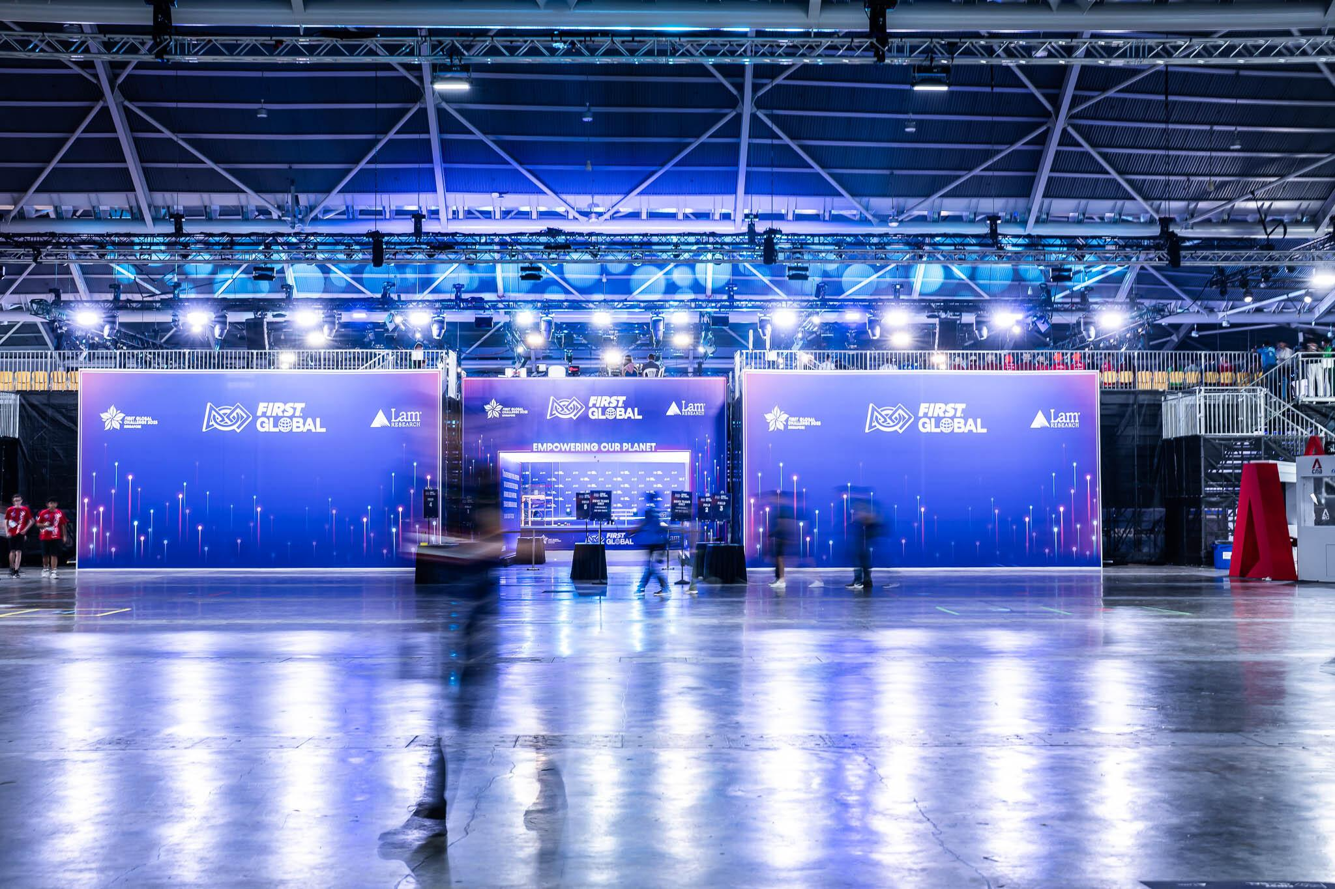

Entrance to fields and back of seating

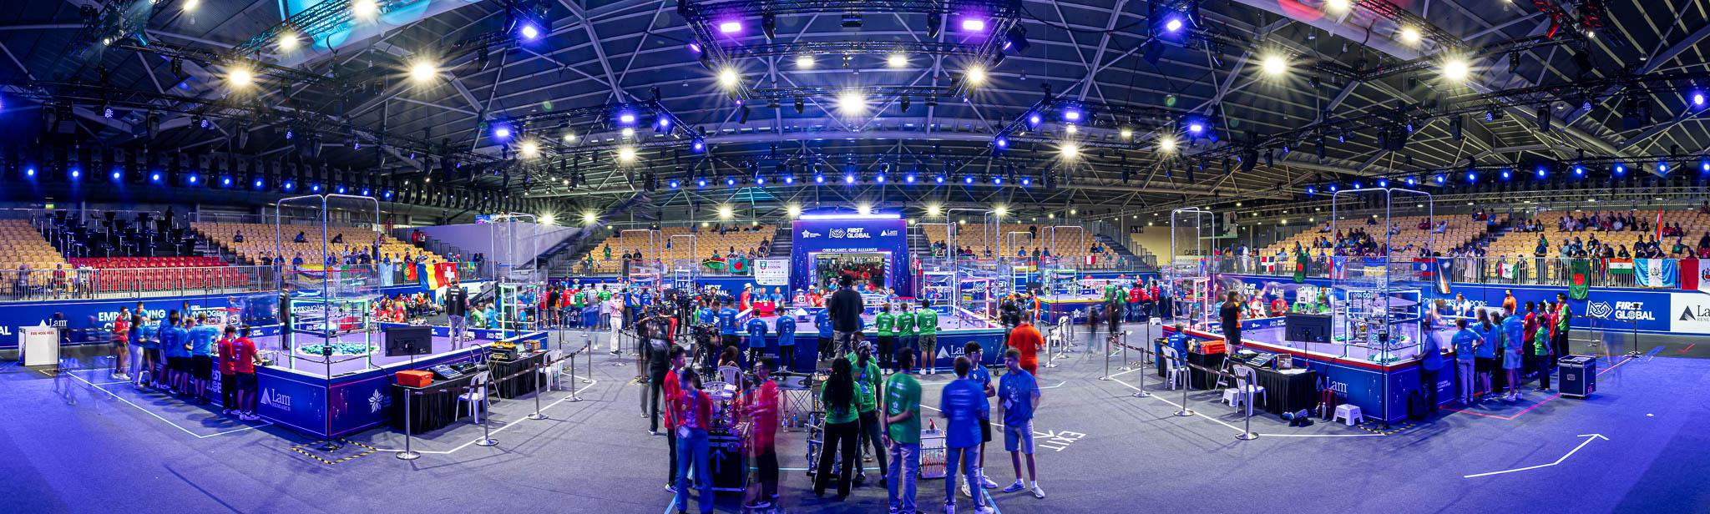View of playing fields and seating, from the stage

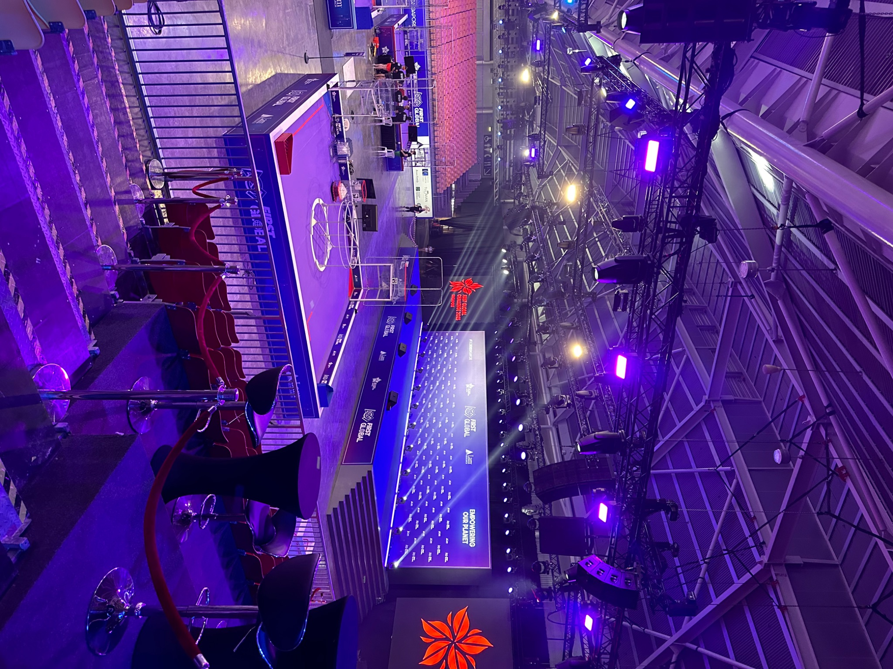
View of Main Stage

Playing Fields
- FIRST Global uses 5 playing fields with 2-3 matches taking place at the same time. There is one main field that is used for the live broadcast that has sports-style commentary.
- The playing fields all require an elevated platform and power access.
- Layout of the fields may vary each year depending on the venue.
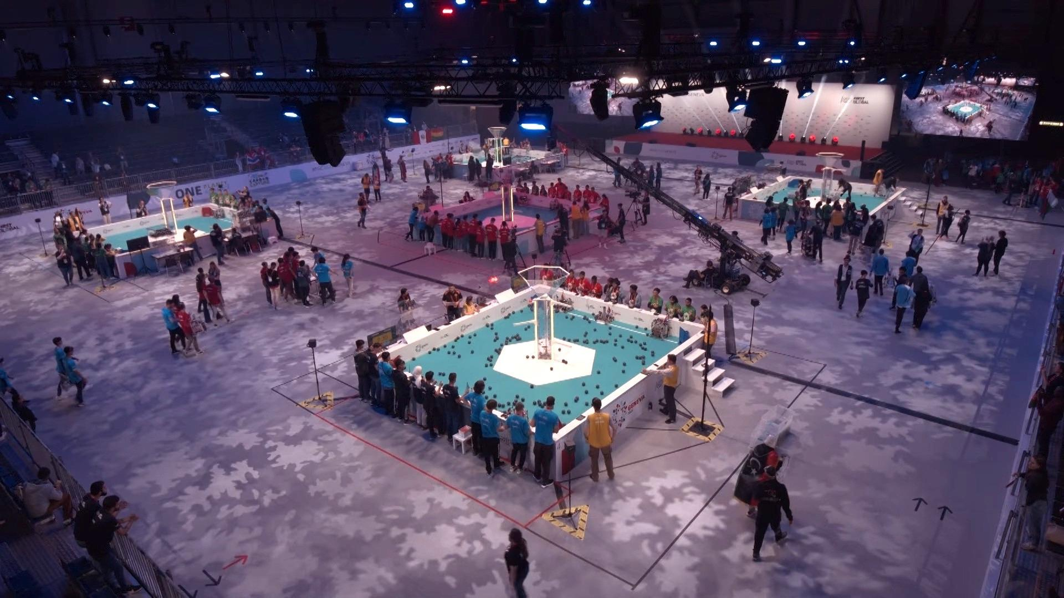
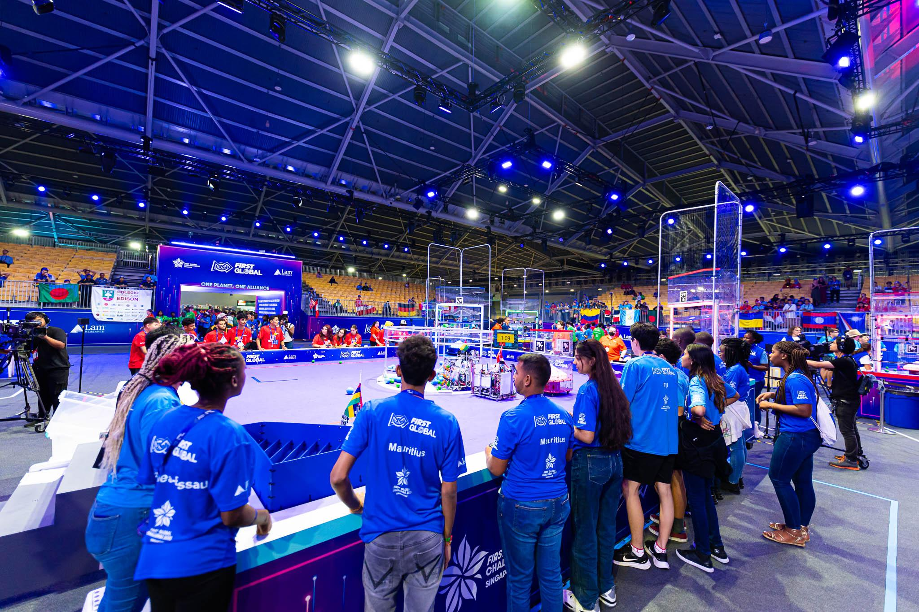

Pits
- The “Pits” is a large area where all teams have an exposition-style 3x3 m booth separated by a half-wall; 1 booth per team, with individual power drops and 1 table.
- Arranged in alphabetical order with flag and country name displayed
- Also within this area is the “Pit Admin” area which is a large booth with counters and a live mic for announcements, and acts as a central information hub for the teams
- There are also two practice fields (same size as the main playing fields) within, or close to, this area.

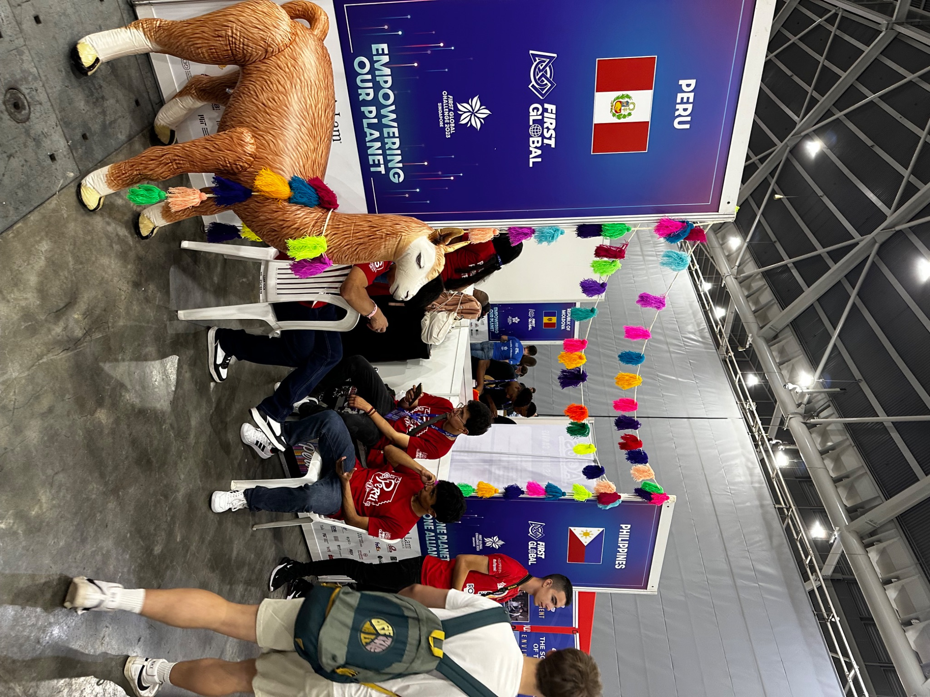

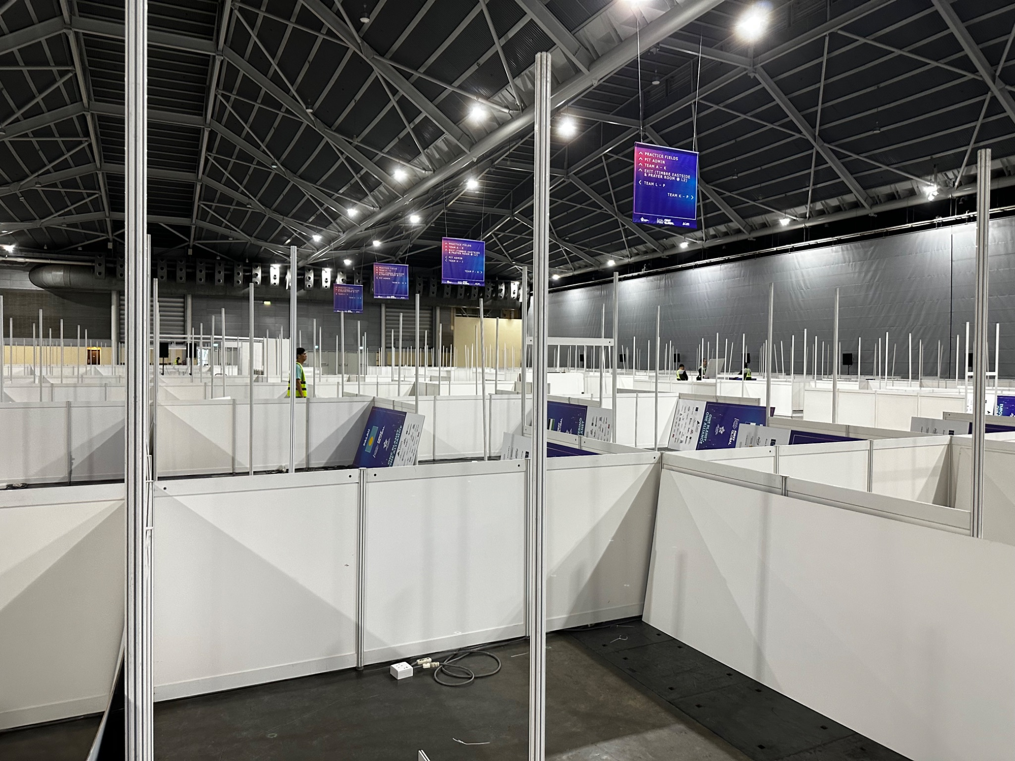
View of unfinished pits

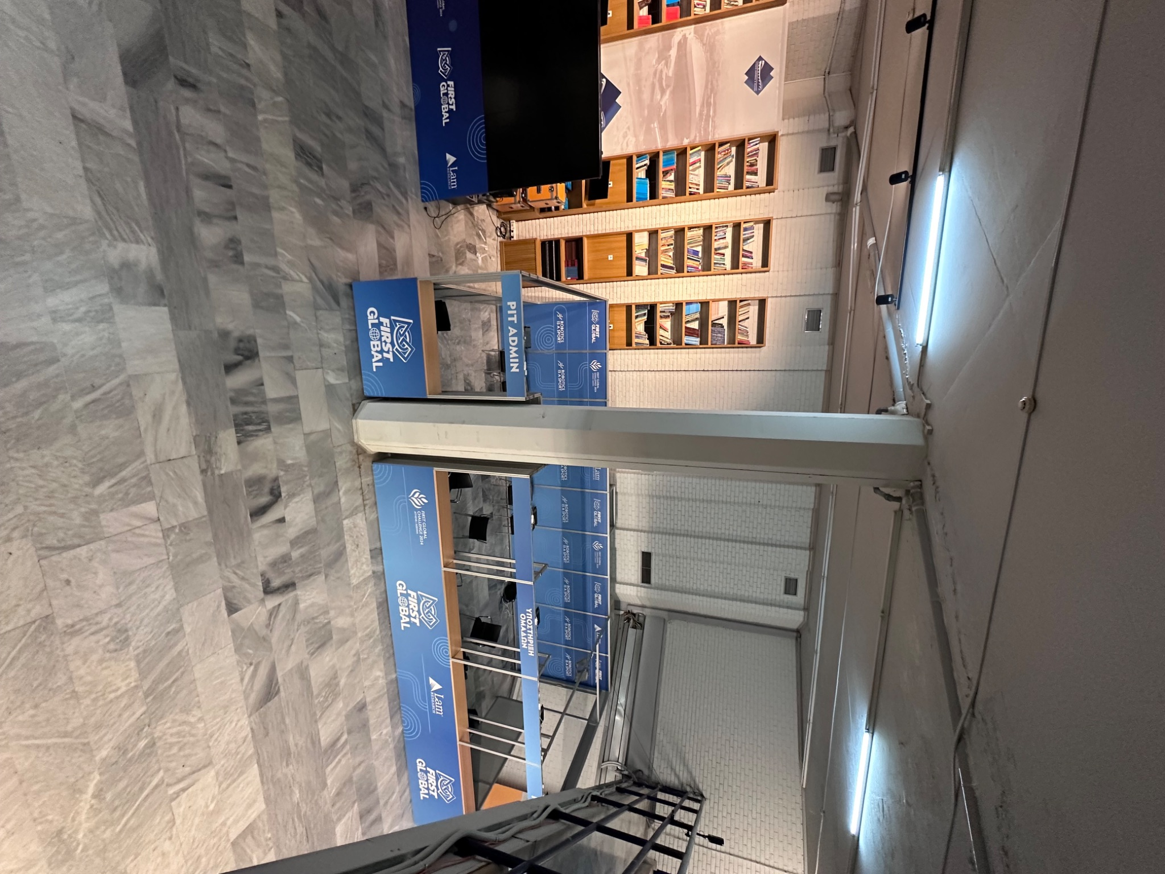
View of Pit Administration Area

Robot Hospital
- Large expo style structure that houses spare robot parts, machine shop, and work area for teams experiencing issues with their robots; has different windows so students can queue up for help or access to spare parts

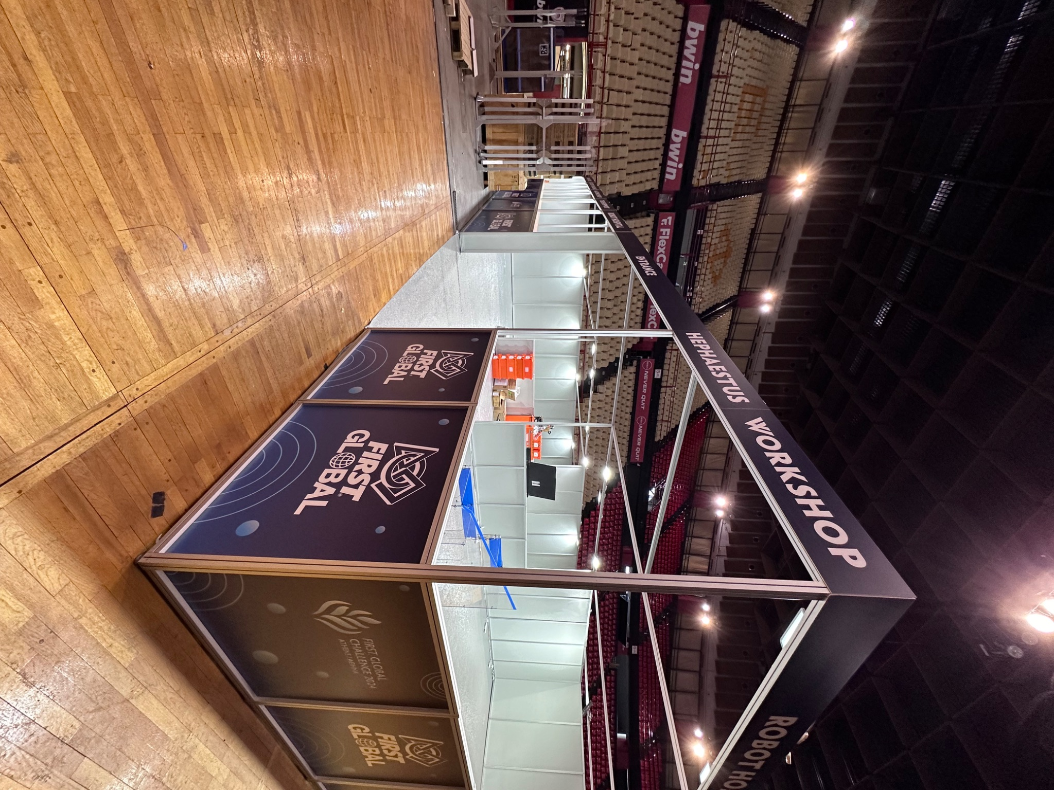

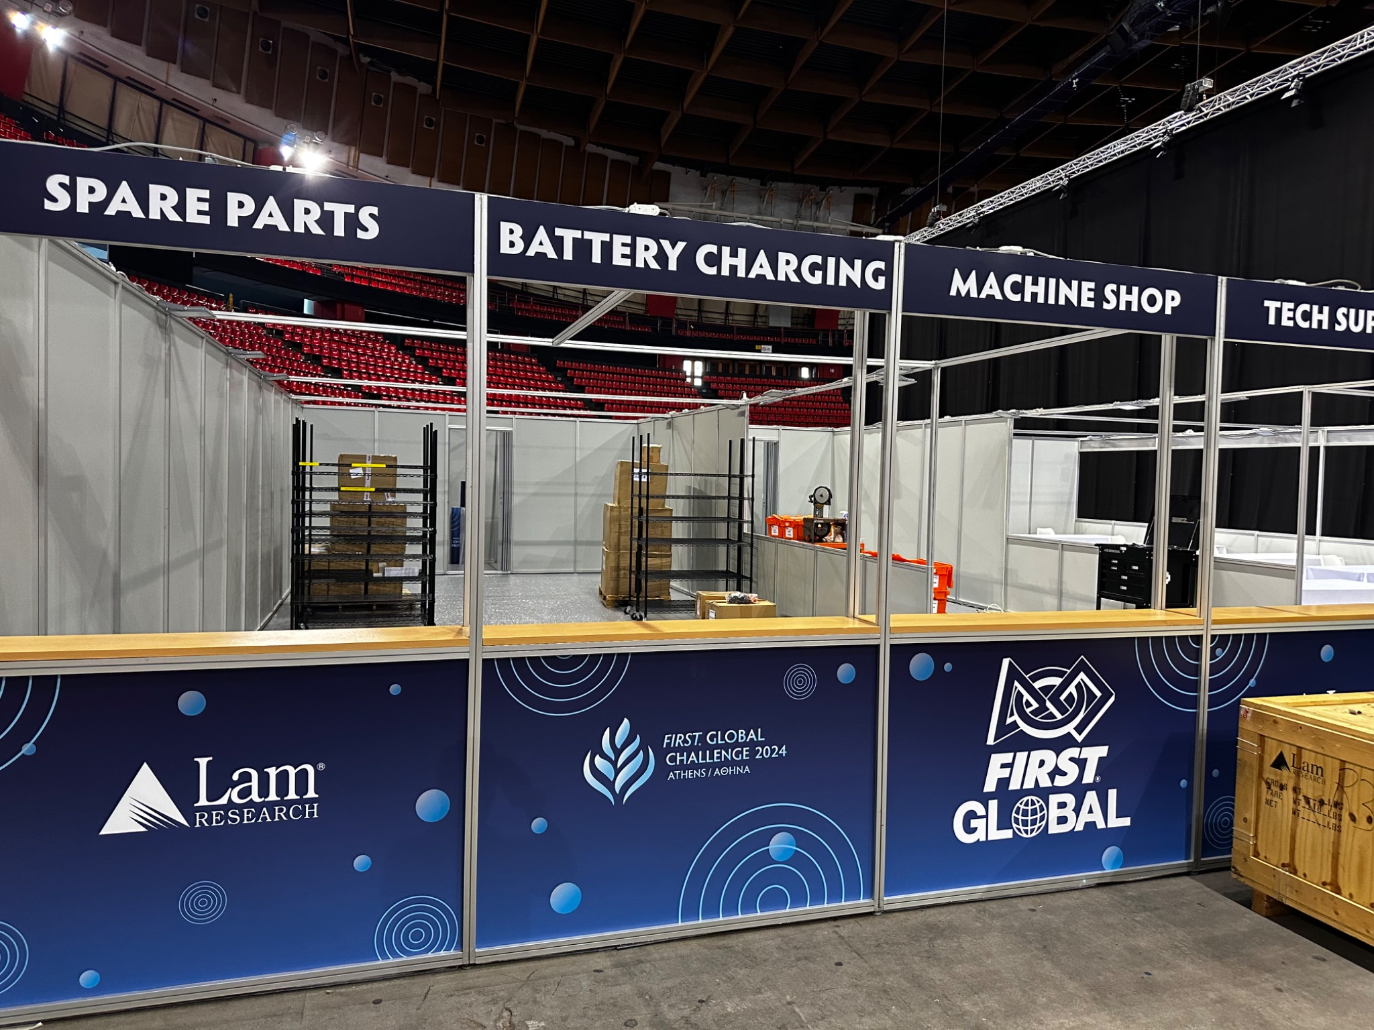

Exposition Area
- Individual sponsors and partners will have tables and booths in an area at the venue
- Each should have power and some may be custom-built structures
- Some Expo booths are custom-built structures, others are tables provided to the guest

Sample Layout
Below is a sample layout of the 2022 FIRST Global Challenge that showcases many of the different areas above to show scale and scope.

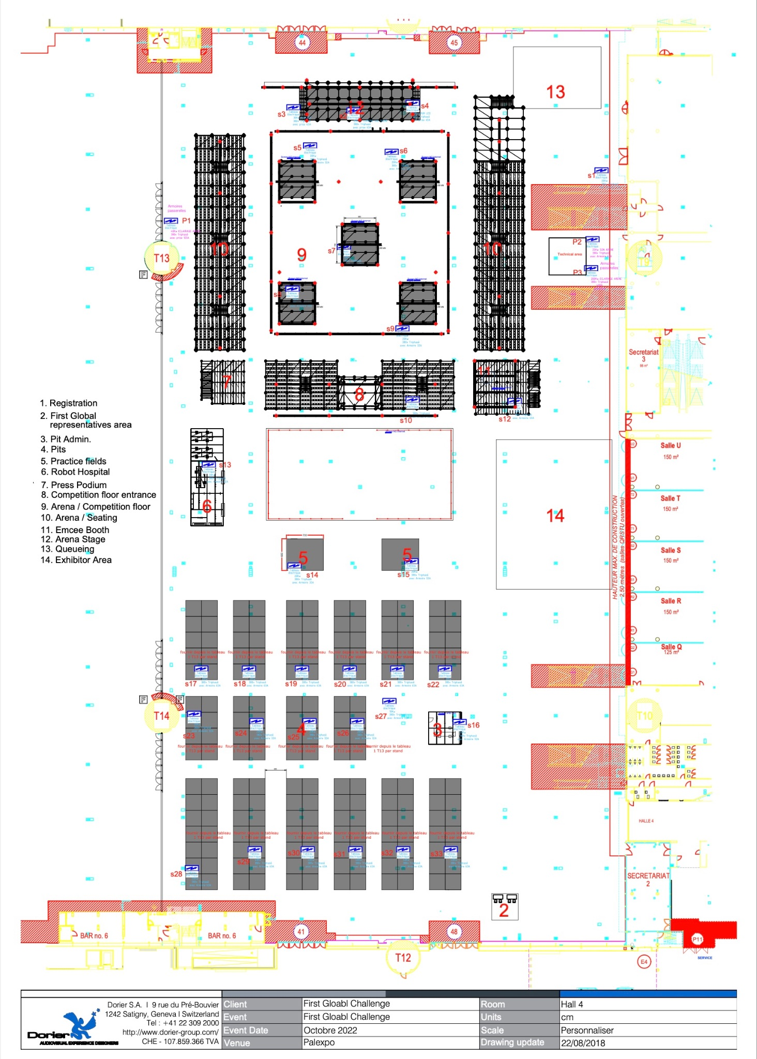
Geneva, PalExpo

